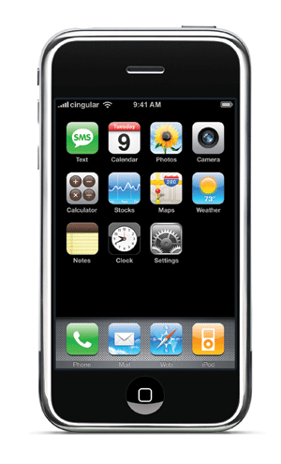
iPhone/iTouch Development Group – UNC Chapel Hill

Mobile Computing
“Mobile computing is a generic term describing one's ability to use technology while moving, as opposed to portable computers, which are only practical for use while deployed in a stationary configuration. Mobile computing is a generic term describing one's ability to use technology while moving, as opposed to portable computers, which are only practical for use while deployed in a stationary configuration.” (Wikipedia, “Mobile Computing,” 2009)

iPhone/iTouch Itself
- Multi-Touch
- Accelerometer
- GPS
- Internet – Mobile Browsing
- ACTIVE Application Development Community

Applications

- Writing Pad - Trace Words instead of typing them... fast typing.
- Facebook
- Lose It - Track calories eaten - GREAT APP
- Ocarina - Play music on phone by blowing in mic.
- Shazam - listen to music and identify
- iTV - TV guide for the phone
- Joost - Video (National Geographic, CBS content and lots more)
- Last FM or Pandora
- Sports Tap (my choice for getting score updates.. all sports!)
- Mint (Money Manager)
- Say Who (Voice Dial)
- Say Where (Voice Search)
- Around Me (GPS stuff around)
- SnapTell (Take pictures of books, DVD's, CD, etc and search for price/reviews)
- AirShare (Get docs and other stuff on phone easily)
- Voice Note, Jott, QuickVoice (Voice recording stuff)
- Fring (Instant Messaging/voice calls)
- Google Mobile App (search with voice)
- Animoto (create music video from photos and music)
- Fluke (Stumble upon for apps... just click a button to see a new random app.. can categorize too)
- WRAL (our local weather station... has video too) or WeatherChannel
- Vlingo (update social networks and other stuff with voice)
- Flashlight
- NextBus (find when busses are coming in chapel hill)
- TouchTerm (SSH client for iphone)
- GPS Tracker (allow others to track you on a map.. I used on trip to Texas, family LOVED it!)
- Craigsphone (Craigslist on the phone)
- Loopt (Social network on phone... with GPS... pretty cool)
- Night Stand
- Remember the Milk (ToDo $$)
- SpeedReader (still a bit buggy, but it is a flash player)
- EasyWiFi (makes easy to connect at StarBucks
- TED (Video from TED tech stuff)
- UrbanSpoon (look for places to eat... random)
Games:
- Koi Pond (.99)
- T4Two Free (old pong.. with accelerometer) Free and Fun
- AirHockey
- Labrinth Lite (old marble in wooden maze)
- Tetris ($$)
- Crash Bandicott ($$)
- Super Monkeyball ($$)
- Trace
Jailbroken Apps
- Cycorder - Video recording
- PDA Net - Modem for 3G on computer - free for web, $30 to open all ports (for remote desktop and the like)
- Categories (Put apps in folders)
- Backgrounder (run apps in the background... sucks the battery though)
- Winterboard - Get themes on your iphone
- StumblerPlus (Discover nearby WiFi networks and a LOT of info about them)
- Airhorn
How to Jailbreak iPhone
- QuickPWN - http://www.quickpwn.com

Other Universities
Abilene Christian University
- Mobile Website - http://m.acu.edu/acu-mobile/
Stanford:
- Stanford Suite - http://stanford.terriblyclever.com/
- Terribly Clever - http://terriblyclever.com/
Duke University

Group:
We have a group of about 30 people from all around campus that are interested in doing something here on campus, but no official direction from any one group. We have met once for lunch to discuss ideas, but mostly we just correspond over a listserv.
Iphone-interest@listserv.unc.edu

App Ideas:
- First and foremost we wanted to do something like Stanford and Duke’s suite of applications. We thought a map would be a good start.
- A second idea was to create a grading/attendance application for professors. Kathy Vreeland up in OASIS has started working on this and has made some good progress in her spare time.

Web Development for iPhone
Web development really seems like one of the best ways to approach iPhone development at UNC. It doesn’t require learning too much programming, and in some cases, just requires installing a plugin or component to an existing CMS.
- Wordpress Plugin will format pages for iPhone – WPTouch - http://www.bravenewcode.com/wptouch/
- Joomla Plugin – JC-iJoom - http://www.joomlahacks.com/component/option,com_remository/Itemid,41/func,fileinfo/id,483/
- iUi – User Interface Development for the iPhone - http://code.google.com/p/iui/ (Chad Haefele has been playing with this for the Davis Library System - http://www.hiddenpeanuts.com/iphonetest/#_home )
- Turn any RSS into an Iphone interface - http://css-tricks.com/create-a-slick-iphonemobile-interface-from-any-rss-feed/
- IUIWebView - http://www.iphonesdkarticles.com/2008/08/uiwebview-tutorial.html - wrap up a working web page in, and have nearly exactly the same web app running on the iPhone without waiting for a web page download..

SDK
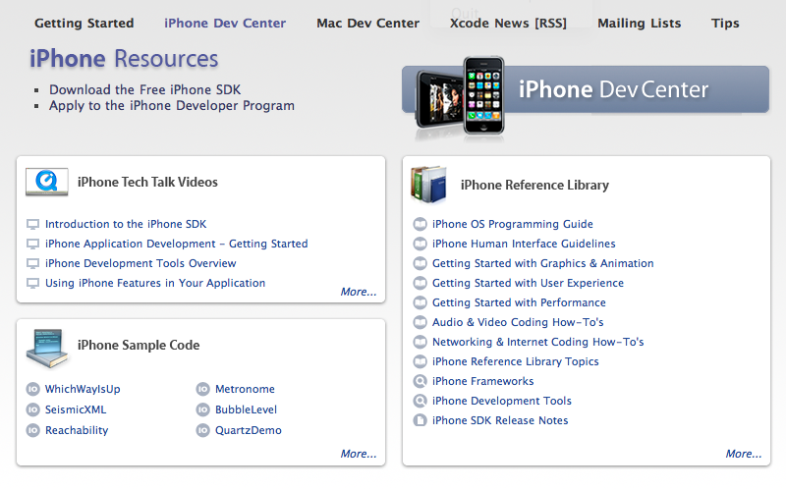

Code Helps and Examples:
- Apple iPhone Dev Center - http://developer.apple.com/iphone/
- http://www.stanford.edu/class/cs193p/cgi-bin/index.php - Course Notes and Code
- http://www.stanfordiphoneclassapps.com
- BYU CocoaHeads - http://cocoaheads.byu.edu/resources
- VixML - http://vixml.com/ - Graphical iPhone Development Software.

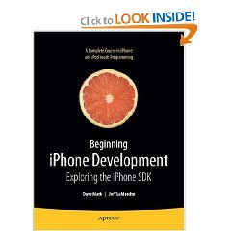
Programming:
- Learn C for Cocoa - http://cocoadevcentral.com/articles/000081.php
- Learn Objective C - http://cocoadevcentral.com/d/learn_objectivec/
- Beginning iPhone Development: Exploring the iPhone SDK (Beginning from Novice to Professional) (Paperback) by Dave Mark (Author), Jeff LaMarche (Author) ISBN-10: 1430216263
- Learn Objective–C on the Mac (Learn Series) (Paperback) by Mark Dalrymple (Author), Scott Knaster (Author) ISBN-10: 1430218150
- Learn C on the Mac (Learn Series) (Paperback) by Dave Mark (Author) ISBN-10: 1430218096

Licensing:
- iPhone Developer Program - http://developer.apple.com/iphone/program/
- Standard Program - $99 – OASIS has a license and as far as I can tell they are the only one’s on campus
- Enterprise Program
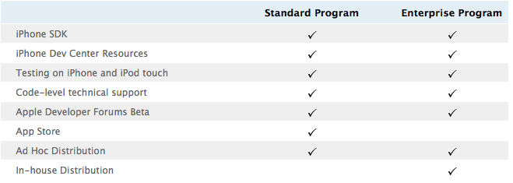

Upcoming Events:
- On Campus Training - March 19th 2-4pm (Location TBA)
- Duke University – May 27th & 28th 2009 – Apple Education Seminar – Academix
  - Wednesday (27th) – Preconference Training Sessions – One will be about iPhone development (one about Podcasts)
  - Thursday (28th) – Basically using Apple products in higher education. Content creation, iTunesU, mobile devices and more.
  - Cost - $FREE$ - Go here to register - http://www.apple.com/education/academix/

